**Step 1: Connect to Azure Cloud Shell**

1. Go to the [Azure Portal](https://portal.azure.com).

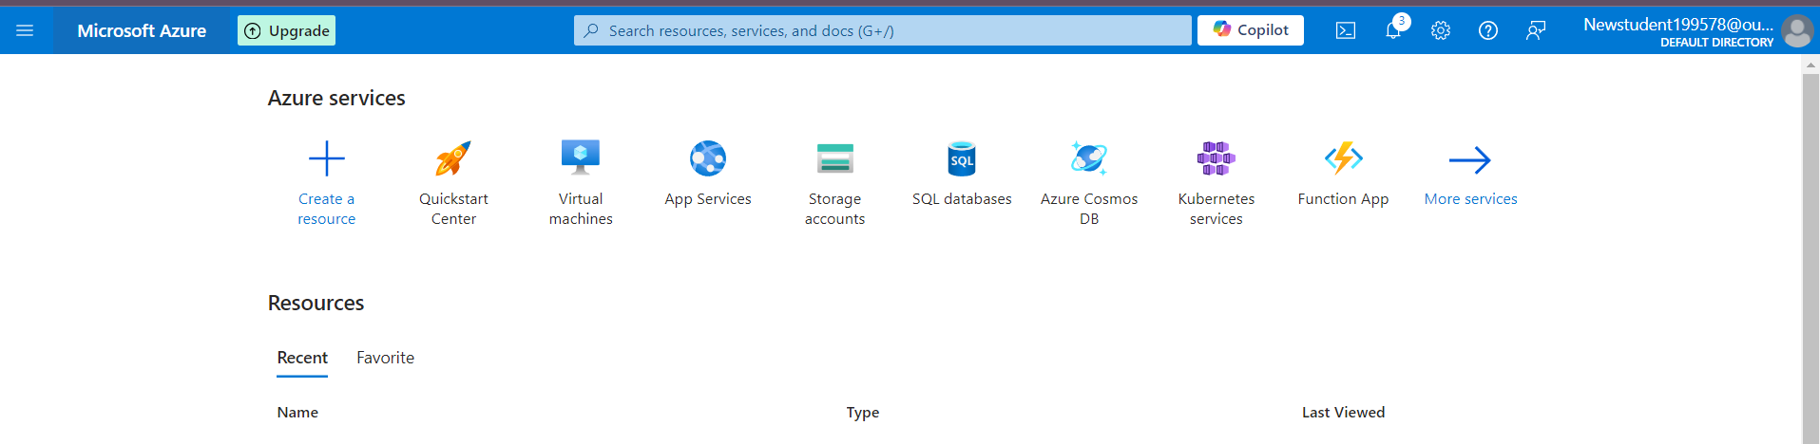

1. Click on the **Cloud Shell** icon (a terminal icon) at the top-right corner of the portal.

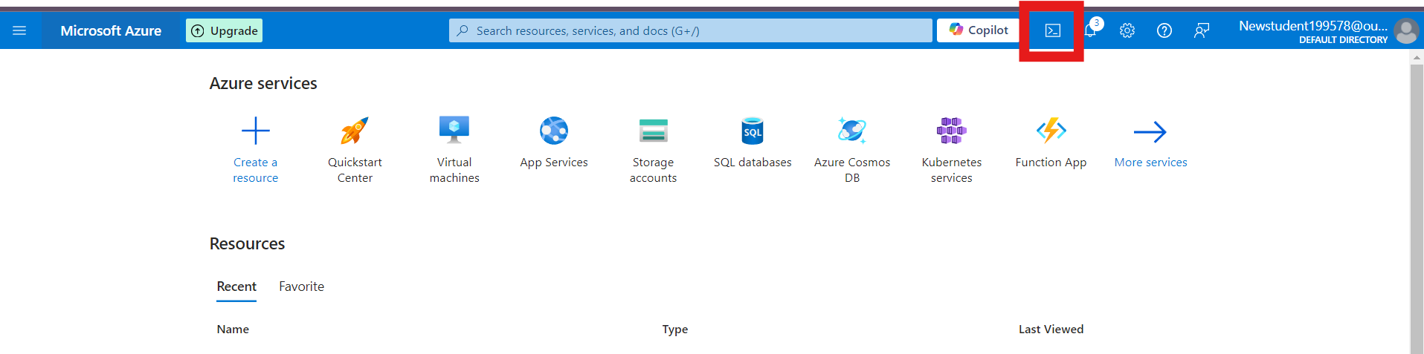

1. Select **Bash**.



1. The Cloud Shell will automatically connect to your Azure environment.

**Step 2: Create a Resource Group**

Once inside Cloud Shell:

**Bash:**

1. Run the following command to create the resource group:

**az group create --name new-rg --location southcentralus**

